THEORY QUESTIONS
1.
(a)

In a school of 255 students, 80 of them study Arabic only and 125 study French only. Each student studies at least one of the two subjects.
(i)

Draw a Venn diagram to represent the information.
(ii)

How many students study
(α)

both subjects?
(β)

French?
(b)

Make h the subject of v =
1
3
πr²h.
(c)

A bookseller bought 80 copies of books at GH₵ 3.50 per copy. He sold each of them at GH₵ 4.20. Find
(i)

the total cost price;
(ii)

his percentage profit.

2.
(a)

The pie chart below shows the distribution of exercise books to six schools A, B, C, D, E and F in a town. School D was given 8,000 exercise books.
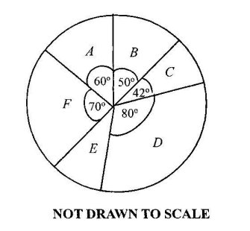
(i)

How many exercise books were given to each of the rest of the school?
(ii)

What is the average number of exercise books given to the schools?
(iii)

How many schools had less than the average number of exercise books?
(b)

Solve the inequality below and illustrate the answer on the number line.
1
3
x + 1 ≥
1
2
x +
1
4
(2 - x)

3.
(a)

Using a ruler and a pair of compasses only, construct
(i)

triangle ABC such that |AB| = 8 cm, angle CBA = 45º and angle CAB = 60º.
(ii)

the bisector of angle ACB to meet |AB| at T.
(b)

Measure
(i)

|CT|;
(ii)

angle CTB.
(c)

A boy spent
3
8
of his money and had GH₵ 15.00 left. How much did he have?

4.
(a)

The perimeter of a rectangular plot of land whose length is (2x + 5) m and width (x -10) m is 80 m. Find the
(i)

value of x;
(ii)

area of the plot;
(iii)

cost of weeding the plot at GH₵ 0.24 per m²
(b)

Find the value of x and w in the diagram below if |AB| = |BC|.
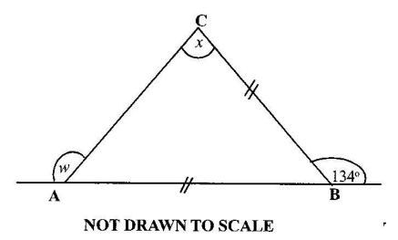

5.
(a)

Given that a =
(
-3
3
)
and b =
(
4
-6
)
, calculate
(i)

a + 2b;
(ii)

1
2
(2a - b)
(b)

The number of pupils in a primary school is given in the table below:
Class | One | Two | Three | Four | Five | Six
Number of pupils | 24 | 35 | 35 | 20 | 21 | 45
(i)

Find the number of pupils in the school.
(ii)

What is the mean number of pupils in a class?
(iii)

What percentage of pupils are in class six?
(c)

Convert 312_{five} to base ten numeral.

6.
(a)

Copy and complete the table for the relation y =
x
20
, where y is the cost(in Ghana cedis) and x is the weight (in grammes) of rice sold in a market.
x (weight in grammes) | 50 | 100 | 150 | 200 | 250 | 300
y (cost in GH₵) |  | 5.00 |  |  | 12.50
(b)

(i)

On a graph sheet, draw two perpendicular axes OX and OY.
(ii)

Using a scale of 2 cm to 50 grammes on the x-axis and 2 cm to GH₵ 2.00 on the y-axis draw the graph of the relation y =
x
20
.
(c)

Using the graph, find
(i)

the cost of 175 grammes of rice;
(ii)

the weight of rice that can be bought with GH₵ 14.00

